Yellow | Yellow | Yellow | Yellow
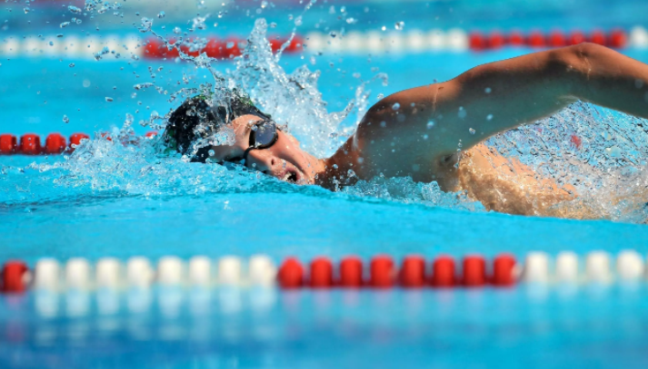  - Swimming  - Roller skating  - Sail  - Ice skating | 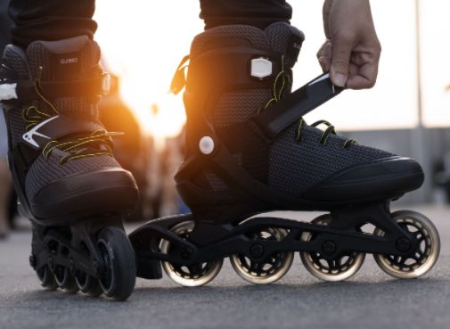  - Swimming  - Roller skating  - Sail  - Ice skating | 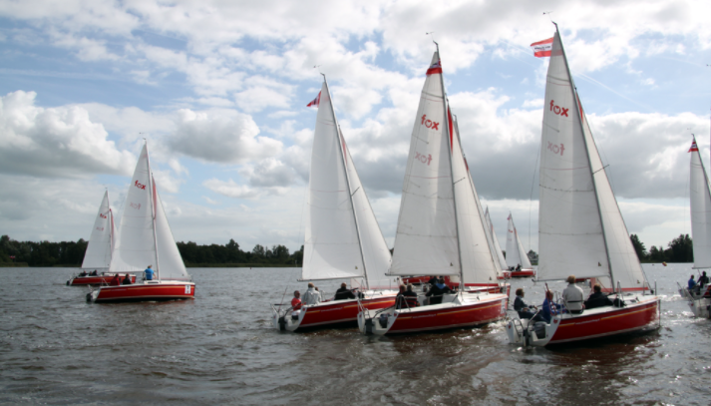  - Swimming  - Roller skating  - Sail  - Ice skating | 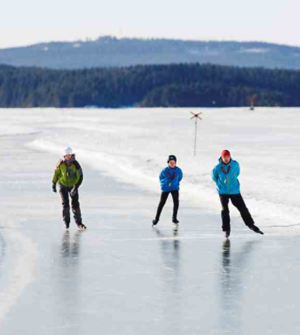  - Swimming  - Roller skating  - Sail  - Ice skating
Green | Green | Green | Green
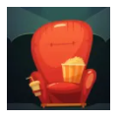  - Cinema  - Tennis  - Playing Guitar  - Football | 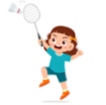  - Cinema  - Tennis  - Playing Guitar  - Football | 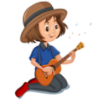  - Cinema  - Tennis  - Playing Guitar  - Football | 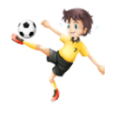  - Cinema  - Tennis  - Playing Guitar  - Football

Blue | Blue | Blue | Blue
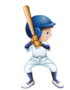  - Baseball  - Playing video games  - Reading books  - Horse riding | 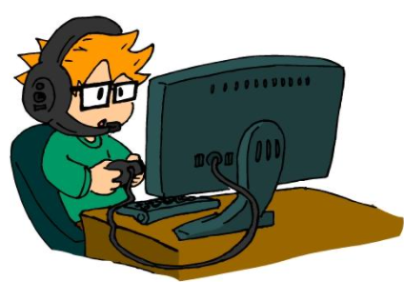  - Baseball  - Playing video games  - Reading books  - Horse riding | 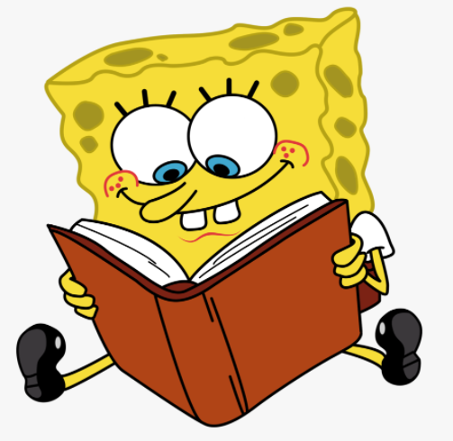  - Baseball  - Playing video games  - Reading books  - Horse riding | 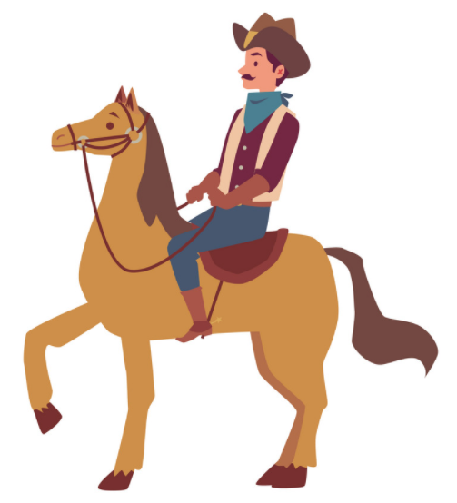  - Baseball  - Playing video games  - Reading books  - Horse riding
Purple | Purple | Purple | Purple
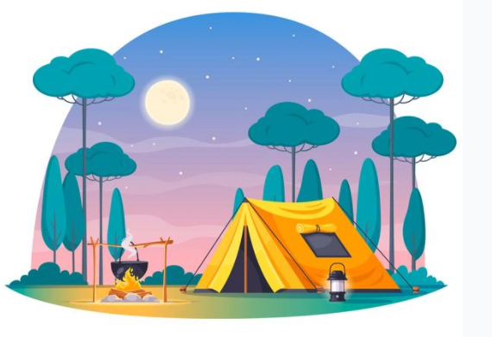  - Camping  - Do karate  - Playing the piano  - Do a puzzle | 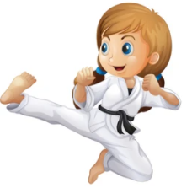  - Camping  - Do karate  - Playing the piano  - Do a puzzle | 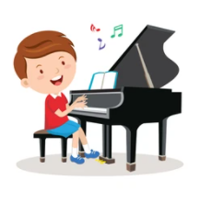  - Camping  - Do karate  - Playing the piano  - Do a puzzle | 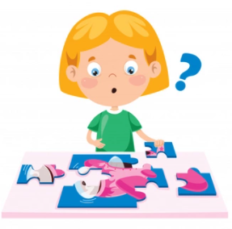  - Camping  - Do karate  - Playing the piano  - Do a puzzle

Pink | Pink | Pink | Pink
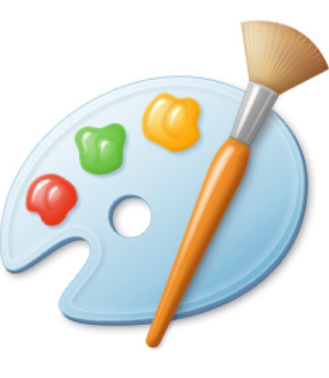  - Painting  - Knitting  - Papier-mâché  - Pottery | 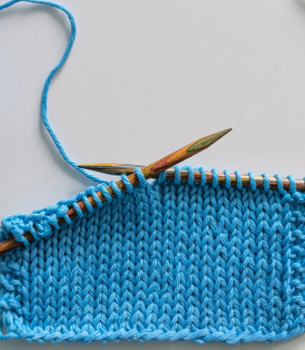  - Painting  - Knitting  - Papier-mâché  - Pottery | 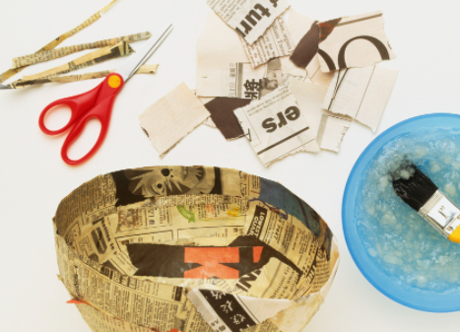  - Painting  - Knitting  - Papier-mâché  - Pottery | 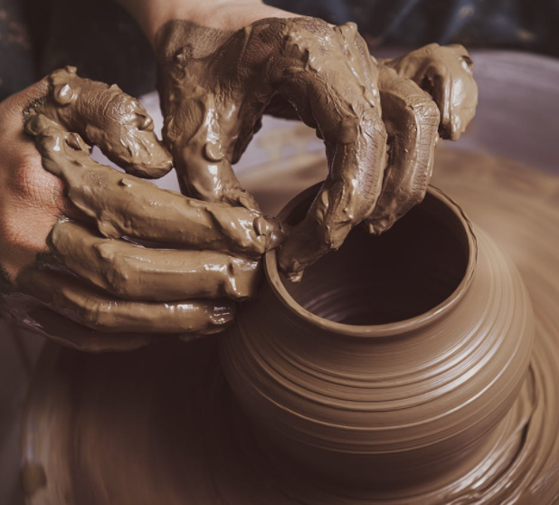  - Painting  - Knitting  - Papier-mâché  - Pottery
Red | Red | Red | Red
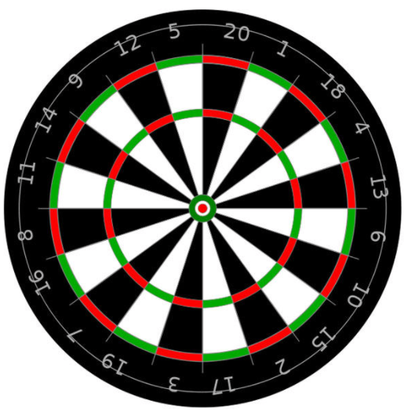  - Darts  - Chess  - Ballet  - Ventriloquy | 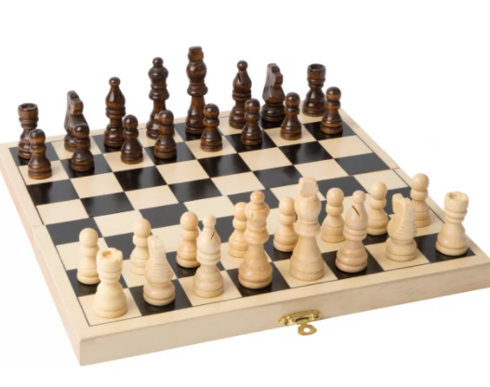  - Darts  - Chess  - Ballet  - Ventriloquy | 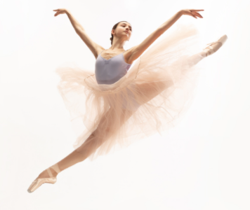  - Darts  - Chess  - Ballet  - Ventriloquy | 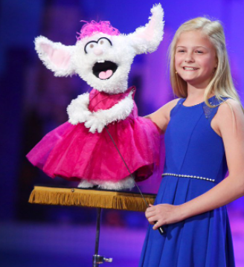  - Darts  - Chess  - Ballet  - Ventriloquy

Orange | Orange | Orange | Orange
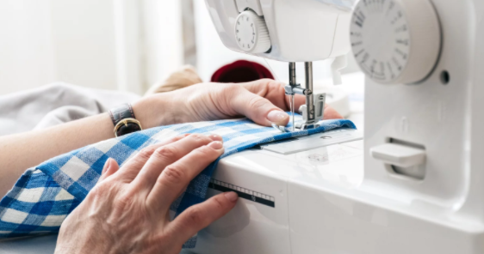  - Sewing  - Flying a kite  - Baking  - Dancing | 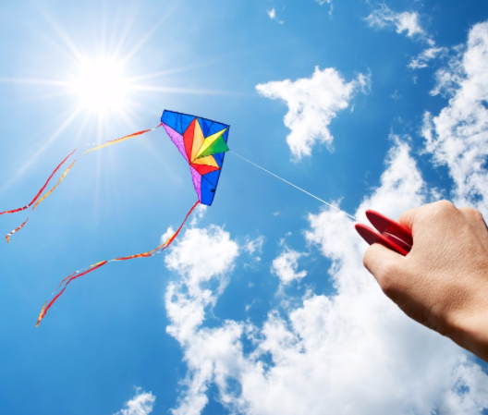  - Sewing  - Flying a kite  - Baking  - Dancing | 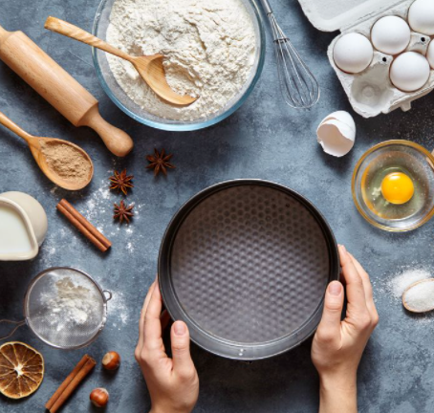  - Sewing  - Flying a kite  - Baking  - Dancing | 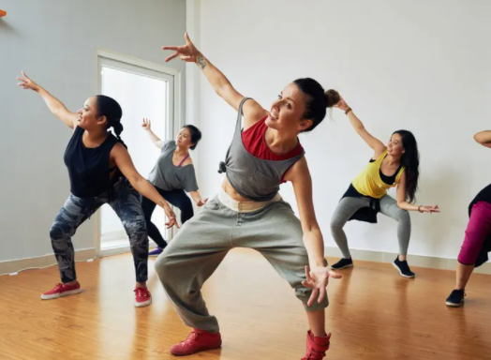  - Sewing  - Flying a kite  - Baking  - Dancing
Brown | Brown | Brown | Brown
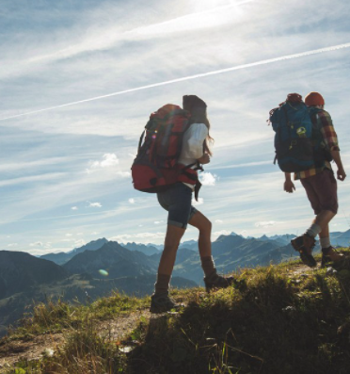  - Hiking  - Fishing  - Table tennis  - Long jump | 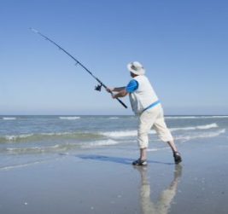  - Hiking  - Fishing  - Table tennis  - Long jump | 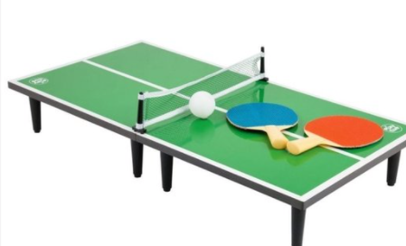  - Hiking  - Fishing  - Table tennis  - Long jump | 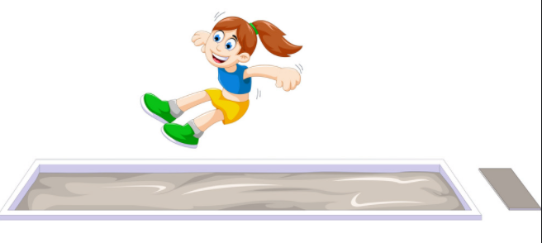  - Hiking  - Fishing  - Table tennis  - Long jump

