Yellow | Yellow | Yellow | Yellow
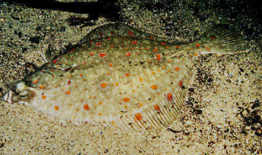  - Sturgeon  - Newt  - Carp  - Plaice | 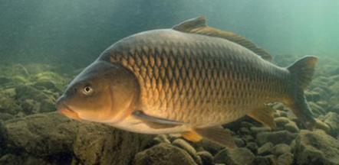  - Sturgeon  - Newt  - Carp  - Plaice | 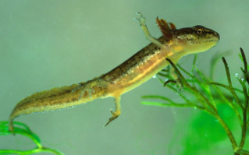  - Sturgeon  - Newt  - Carp  - Plaice | 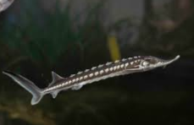  - Sturgeon  - Newt  - Carp  - Plaice
Green | Green | Green | Green
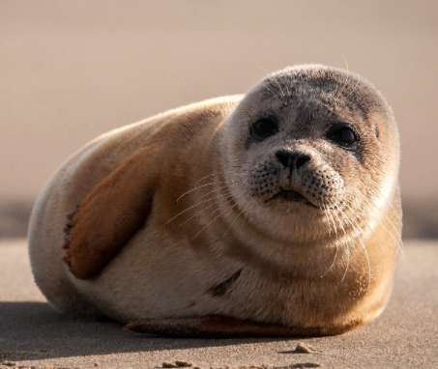  - Seal  - Whale  - Dolphin  - Seahorse | 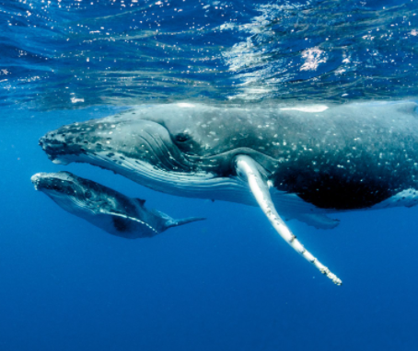  - Seal  - Whale  - Dolphin  - Seahorse | 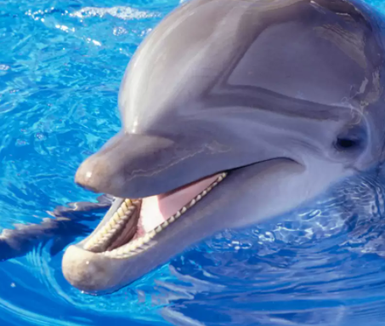  - Seal  - Whale  - Dolphin  - Seahorse | 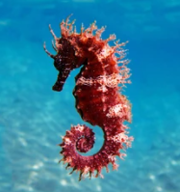  - Seal  - Whale  - Dolphin  - Seahorse

Blue | Blue | Blue | Blue
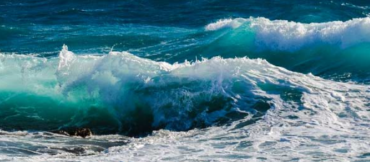  - Waves  - Shore  - Ocean floor  - Seaweed | 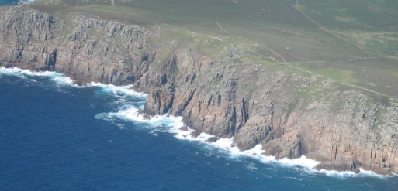  - Waves  - Shore  - Ocean floor  - Seaweed | 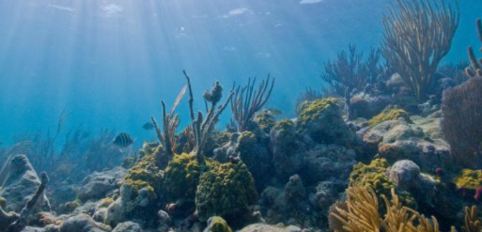  - Waves  - Shore  - Ocean floor  - Seaweed | 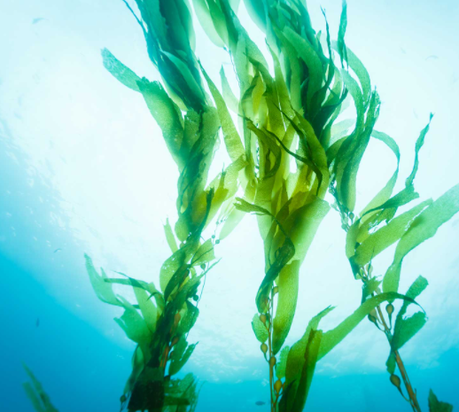  - Waves  - Shore  - Ocean floor  - Seaweed
Purple | Purple | Purple | Purple
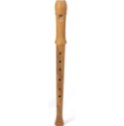  - Flute  - Bass  - Tuba  - Harp | 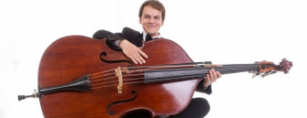  - Flute  - Bass  - Tuba  - Harp | 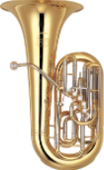  - Flute  - Bass  - Tuba  - Harp | 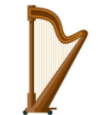  - Flute  - Bass  - Tuba  - Harp

Pink | Pink | Pink | Pink
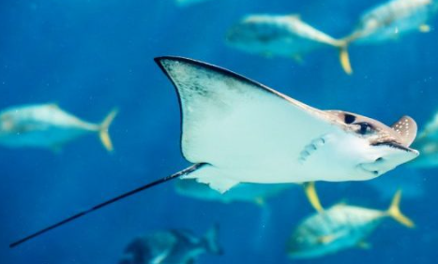  - Ray  - Blowfish  - Trout  - Bass | 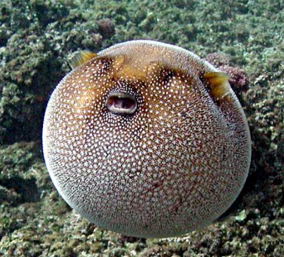  - Ray  - Blowfish  - Trout  - Bass | 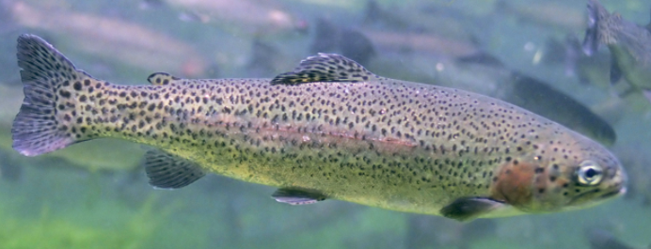  - Ray  - Blowfish  - Trout  - Bass | 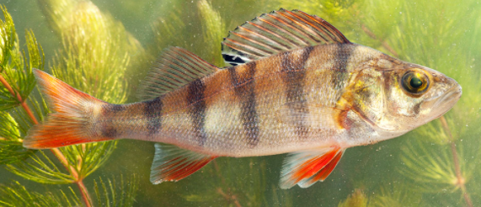  - Ray  - Blowfish  - Trout  - Bass
Red | Red | Red | Red
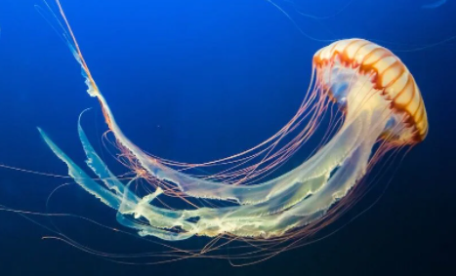  - Jellyfish  - Squid  - Octopus  - Starfish | 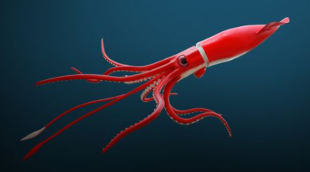  - Jellyfish  - Squid  - Octopus  - Starfish | 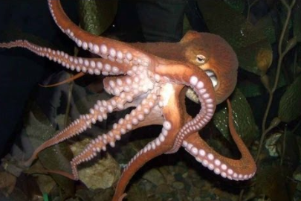  - Jellyfish  - Squid  - Octopus  - Starfish | 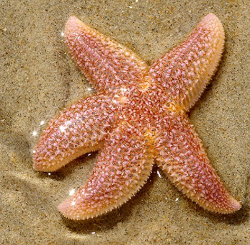  - Jellyfish  - Squid  - Octopus  - Starfish

Orange | Orange | Orange | Orange
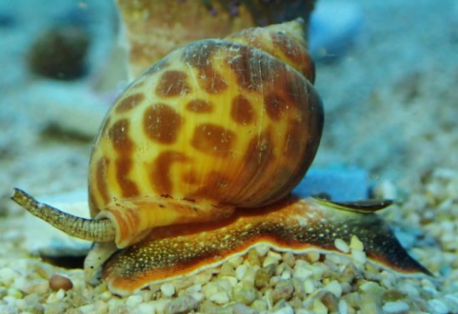  - Clownfish  - Sardine  - Clam  - Snail | 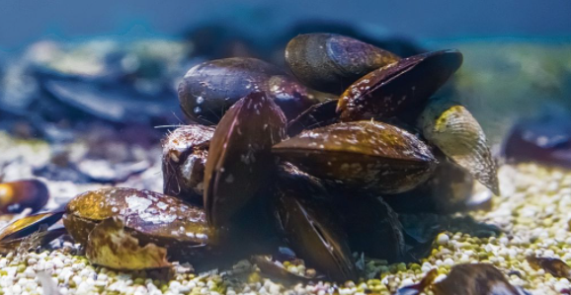  - Clownfish  - Sardine  - Clam  - Snail | 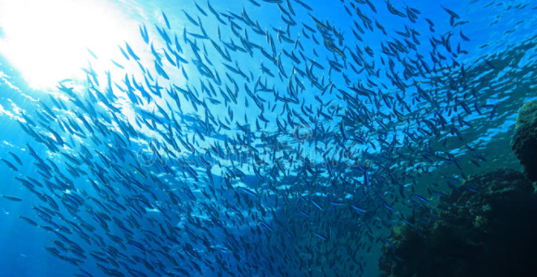  - Clownfish  - Sardine  - Clam  - Snail | 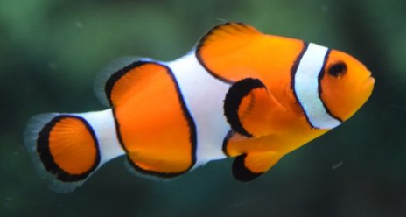  - Clownfish  - Sardine  - Clam  - Snail
Brown | Brown | Brown | Brown
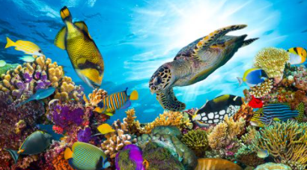  - Lake  - Bowl  - Plate  - Sea | 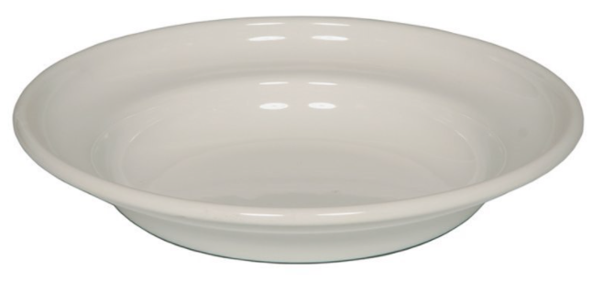  - Lake  - Bowl  - Plate  - Sea | 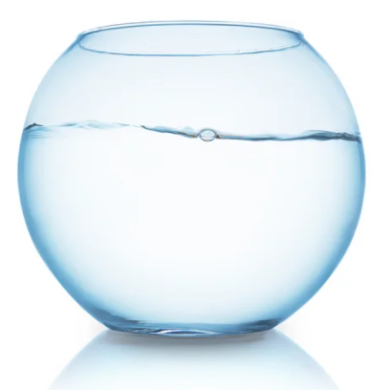  - Lake  - Bowl  - Plate  - Sea | 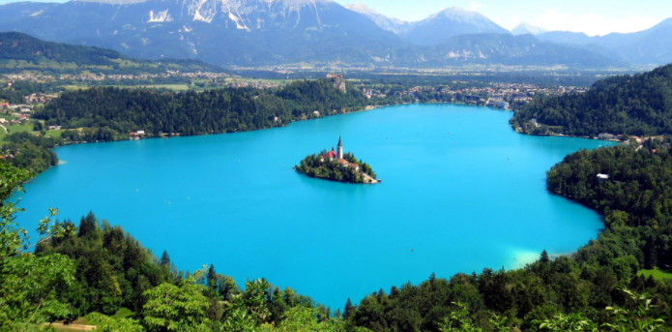  - Lake  - Bowl  - Plate  - Sea

